3GPP TS 45.001 V4.0.0 (2000-09)
Technical Specification
3rd Generation Partnership Project;
Technical Specification Group GERAN;
Digital cellular telecommunications system (Phase 2+);
Physical layer on the radio path;
General description
(Release 4)


The present document has been developed within the 3rd Generation Partnership Project (3GPP TM) and may be further elaborated for the purposes of 3GPP.
The present document has not been subject to any approval process by the 3GPP Organizational Partners and shall not be implemented.
This Specification is provided for future development work within 3GPP only. The Organizational Partners accept no liability for any use of this Specification.
Specifications and reports for implementation of the 3GPP TM system should be obtained via the 3GPP Organizational Partners' Publications Offices.

Keywords
GSM, layer 1, radio
3GPP
Postal address

3GPP support office address
650 Route des Lucioles - Sophia Antipolis
Valbonne - FRANCE
Tel.: +33 4 92 94 42 00 Fax: +33 4 93 65 47 16
Internet
http://www.3gpp.org
Copyright Notification
No part may be reproduced except as authorised by written permission.
The copyright and the foregoing restrictions extend to reproduction in all media.

© 3GPP 2000
All rights reserved.

Contents
Foreword 4
1 Scope 5
1.1 References 5
1.2 Abbreviations 6
2 Set of channels 6
3 Reference configuration 8
4 The block structures 9
5 Multiple access and timeslot structure 12
5.1 Hyperframes, superframes and multiframes 12
5.2 Time slots and bursts 12
5.3 Channel organization 15
6 Frequency hopping capability 16
7 Coding and interleaving 18
7.1 General 18
7.2 Packet Traffic and Control Channels 21
7.2.1 Channel coding for PDTCH 21
7.2.1.1 Channel coding for GPRS PDTCH 21
7.2.1.2 Channel coding for EGPRS PDTCH 21
7.2.2 Channel coding for PACCH, PBCCH, PAGCH, PPCH, PNCH, CPBCCH, CPAGCH, CPPCH, CPNCH, and CSCH 22
7.2.3 Channel Coding for the PRACH 22
8 Modulations 23
9 Transmission and reception 23
10 Other layer 1 functions 24
11 Performance 25
Annex A (informative): Reference configuration 26
Annex B (informative): Relations between specification 27
Annex C (informative): Change control history 28

Foreword
This Technical Specification has been produced by the 3rd Generation Partnership Project (3GPP).
The contents of the present document are subject to continuing work within the TSG and may change following formal TSG approval. Should the TSG modify the contents of the present document, it will be re-released by the TSG with an identifying change of release date and an increase in version number as follows:
Version x.y.z
where:
x the first digit:
1 presented to TSG for information;
2 presented to TSG for approval;
3 or greater indicates TSG approved document under change control.
y the second digit is incremented for all changes of substance, i.e. technical enhancements, corrections, updates, etc.
z the third digit is incremented when editorial only changes have been incorporated in the document.

1 Scope
The present document is an introduction to the 05 series of the digital cellular telecommunications systems GSM technical specifications. It is not of a mandatory nature, but consists of a general description of the organization of the physical layer with reference to the technical specifications where each part is specified in detail. It introduces furthermore, the reference configuration that will be used throughout this series of technical specifications.

1.1 References
The following documents contain provisions which, through reference in this text, constitute provisions of the present document.
- References are either specific (identified by date of publication, edition number, version number, etc.) or non-specific.
- For a specific reference, subsequent revisions do not apply.
- For a non-specific reference, the latest version applies.
[1] 3GPP TR 41.004: "Digital cellular telecommunications system (Phase 2+); Abbreviations and acronyms".
[2] 3GPP TS 43.003: "Digital cellular telecommunications system (Phase 2+); Numbering, addressing and identification".
[3] 3GPP TS 43.020: "Digital cellular telecommunications system (Phase 2+); Security related network functions".
[4] 3GPP TS 43.022: "Digital cellular telecommunications system (Phase 2+); Functions related to Mobile Station (MS) in idle mode and group receive mode".
[5] 3GPP TS 044.003: "Digital cellular telecommunications system (Phase 2+); Mobile Station - Base Station System (MS - BSS) interface; Channel structures and access capabilities".
[6] 3GPP TS 44.008: "Digital cellular telecommunications system (Phase 2+); Mobile radio interface layer 3 specification".
[7] 3GPP TS 44.021: "Digital cellular telecommunications system (Phase 2+); Rate adaptation on the Mobile Station - Base Station System (MS-BSS) Interface".
[8] 3GPP TS 45.002: "Digital cellular telecommunications system (Phase 2+); Multiplexing and multiple access on the radio path".
[9] 3GPP TS 45.003: "Digital cellular telecommunications system (Phase 2+); Channel coding".
[10] 3GPP TS 45.004: "Digital cellular telecommunications system (Phase 2+); Modulation".
[11] 3GPP TS 45.005: "Digital cellular telecommunications system (Phase 2+); Radio transmission and reception".
[12] 3GPP TS 45.008: "Digital cellular telecommunications system (Phase 2+); Radio subsystem link control".
[13] 3GPP TS 45.009: "Digital cellular telecommunications system (Phase 2+); Link adaptation".
[14] 3GPP TS 45.010: "Digital cellular telecommunications system (Phase 2+); Radio subsystem synchronization".
[15] 3GPP TS 43.030: "Digital cellular telecommunications system (Phase 2+); Radio network planning aspects".
[16] 3GPP TS 43.064: "Digital cellular telecommunications system (Phase 2+); General Packet Radio Service (GPRS); Overall description of the GPRS radio interface; Stage 2".
[17] 3GPP TS 43.052: "Digital cellular telecommunications system (Phase 2+); GSM Cordless Telephony System (CTS); Phase 1; Lower layers of the CTS Radio Interface; Stage 2".
[18] 3GPP TS 45.056: "Digital cellular telecommunications system (Phase 2+); GSM Cordless Telephony System (CTS); Phase 1; CTS-FP Radio subsystem".

1.2 Abbreviations
Abbreviations used in the present document are listed in 3GPP TR 41.004 [1].

2 Set of channels
The radio subsystem provides a certain number of logical channels that can be separated into two categories according to 3GPP TS 044.003 [5], 3GPP TS 43.064 [15] and 3GPP TS 43.052 [17]:
1) The traffic channels (TCH): they are intended to carry two types of user information streams: encoded speech and data. The following types of traffic channels are defined: Bm or full-rate (TCH/F), Lm or half-rate (TCH/H), cell broadcast (CBCH), full rate packet data (PDTCH/F) and half rate packet data (PDTCH/H) traffic channels. For the purpose of this series of technical specifications, the following traffic channels are distinguished:
- full rate speech TCH (TCH/FS);
- enhanced full rate speech TCH (TCH/EFS)
- half rate speech TCH (TCH/HS);
- adaptive full rate speech TCH (TCH/AFS);
- adaptive half rate speech TCH (TCH/AHS);
- 28,8 kbit/s full rate data E-TCH (E-TCH/F28.8);
- 32,0 kbit/s full rate data E-TCH (E-TCH/F32.0);
- 43,2 kbit/s full rate data E-TCH (E-TCH/F43.2);
- 14,4 kbit/s full rate data TCH (TCH/F14.4);
- 9,6 kbit/s full rate data TCH (TCH/F9.6);
- 4,8 kbit/s full rate data TCH (TCH/F4.8);
- 4,8 kbit/s half rate data TCH (TCH/H4.8);
- ≤ 2,4 kbit/s full rate data TCH (TCH/F2.4);
- ≤ 2,4 kbit/s half rate data TCH (TCH/H2.4);
- cell broadcast channel (CBCH);
- full rate packet data traffic channel (PDTCH/F) ;
- half rate packet data traffic channel (PDTCH/H).
Adaptive speech traffic channels are channels for which part of the radio bandwidth is reserved for transmission of in band signalling to allow in call adaptation of the speech and channel codec. 8 full rate and 6 half rate block structures are defined for the adaptive traffic channels.
All channels are bi-directional unless otherwise stated. Unidirectional downlink full rate channels, TCH/FD are defined as the downlink part of the corresponding TCH/F. Unidirectional uplink full rate channels are FFS.
The allocated uplink and downlink PDTCH are used independently of each other. Dependent allocation of uplink and downlink is possible.
Multislot configurations for circuit switched connections are defined as multiple (1 up to 8) full rate channels allocated to the same MS. At least one channel shall be bi-directional (TCH/F). The multislot configuration is symmetric if all channels are bi-directional (TCH/F) and asymmetric if at least one channel is unidirectional (TCH/FD).
High Speed Circuit Switched Data (HSCSD) is an example of multislot configuration, in which all channels shall have the same channel mode.
NOTE: For the maximum number of timeslots to be used for a HSCSD configuration, see 3GPP TS 03.34.
Multislot configurations for packet switched connections are defined as multiple (1 up to 8) PDTCH/Us and one PACCH for one mobile originated communication, or multiple (1 up to 8) PDTCH/Ds and one PACCH for one mobile terminated communication respectively, allocated to the same MS. In this context allocation refers to the list of PDCH that may dynamically carry the PDTCHs for that specific MS. The PACCH shall be mapped onto one PDCH carrying one PDTCH/U or PDTCH/D. That PDCH shall be indicated in the resource allocation message (see 3GPP TS 04.60).
Multislot configurations for dual transfer mode are defined as one bi-directional, traffic channel (TCH/H, TCH/F or E-TCH/F) and one packet channel combination. The packet channel combination may consist of one PDTCH/U and one PACCH for one mobile originated communication, or multiple (1 or 2) PDTCH/Ds and one PACCH for one mobile terminated communication respectively, allocated to the same MS. The PACCH shall be mapped onto one PDCH carrying one PDTCH/U or PDTCH/D. That PDCH shall be indicated in the resource allocation message (see 3GPP TS 04.60).
An MS capable of dual transfer mode (DTM) shall support, as a minimum, DTM multislot class 1, which utilises the single-timeslot channelization method, i.e. a single TCH/H plus a single PDTCH/H. On the TCH/H portion of this configuration, the MS shall support the adaptive multirate (AMR) speech coder for voice coding.
2) The signalling channels: these can be sub-divided into (P)BCCH ((packet) broadcast control channel), (P)CCCH ((packet) common control channel), SDCCH (stand-alone dedicated control channel), (P)ACCH ((packet) associated control channel), packet timing advance control channel (PTCCH) and CTSCCH (CTS control channel). An associated control channel is always allocated in conjunction with, either a TCH, or an SDCCH. A packet associated control channel is always allocated in conjunction to one or multiple PDTCH, concurrently assigned to one MS. Two types of ACCH for circuit switched connections are defined: continuous stream (slow ACCH) and burst stealing mode (fast ACCH). For the purpose of this series of technical specifications, the following signalling channels are distinguished:
- stand-alone dedicated control channel, four of them mapped on the same basic physical channel as the CCCH (SDCCH/4);
- stand-alone dedicated control channel, eight of them mapped on a separate basic physical channel (SDCCH/8);
- full rate fast associated control channel (FACCH/F);
- enhanced circuit switched full rate fast associated control channel (E-FACCH/F);
- half rate fast associated control channel (FACCH/H);
- slow, TCH/F or E-TCH/F associated, control channel (SACCH/TF);
- slow, TCH/H associated, control channel (SACCH/TH);
- slow, TCH/F or E-TCH/F associated, control channel for multislot configurations (SACCH/M);
- slow, TCH/F associated, control channel for CTS (SACCH/CTS);
- slow, SDCCH/4 associated, control channel (SACCH/C4);
- slow, SDCCH/8 associated, control channel (SACCH/C8);
- packet associated control channel (PACCH);
- packet timing advance control channel (PTCCH);
- broadcast control channel (BCCH);
- packet broadcast control channel (PBCCH);
- random access channel (i.e. uplink CCCH) (RACH);
- packet random access channel (i.e. uplink PCCCH) (PRACH);
- paging channel (part of downlink CCCH) (PCH);
- packet paging channel (part of downlink PCCCH) (PPCH);
- access grant channel (part of downlink CCCH) (AGCH);
- packet access grant channel (part of downlink PCCCH) (PAGCH);
- notification channel (part of downlink CCCH) (NCH);
- packet notification channel (part of downlink PCCCH) (PNCH);
- CTS beacon channel (part of downlink CTSCCH) (CTSBCH-FB and CTSBCH-SB);
- CTS paging channel (part of downlink CTSCCH) (CTSPCH);
- CTS access request channel (part of uplink CTSCCH) (CTSARCH);
- CTS access grant channel (part of downlink CTSCCH) (CTSAGCH).
All associated control channels have the same direction (bi-directional or unidirectional) as the channels they are associated to. The unidirectional SACCH/MD is defined as the downlink part of SACCH/M.
When there is no need to distinguish between different sub-categories of the same logical channel, only the generic name will be used, meaning also all the sub-categories (SACCH will mean all categories of SACCHs, SACCH/T will mean both the slow, TCH associated, control channels, etc.).
The logical channels mentioned above are mapped on physical channels that are described in this set of technical specifications. The different physical channels provide for the transmission of information pertaining to higher layers according to a block structure.

3 Reference configuration
For the purpose of elaborating the physical layer specification, a reference configuration of the transmission chain is used as shown in annex A. This reference configuration also indicates which parts are dealt with in details in which technical specification. It shall be noted that only the transmission part is specified, the receiver being specified only via the overall performance requirements. With reference to this configuration, the technical specifications in the 05 series address the following functional units:
- 3GPP TS 45.002: burst building, and burst multiplexing;
- 3GPP TS 45.003: coding, reordering and partitioning, and interleaving;
- 3GPP TS 45.004: differential encoding, and modulation;
- 3GPP TS 45.005: transmitter, antenna, and receiver (overall performance).
NOTE: 3GPP TS 45.056 addresses the transmitter and receiver of the CTS-FP.
This reference configuration defines also a number of points of vocabulary in relation to the name of bits at different levels in the configuration. It must be outlined, in the case of the encrypted bits, that they are named only with respect to their position after the encryption unit, and not to the fact that they pertain to a flow of information that is actually encrypted.

4 The block structures
The different block structures are described in more detail in 3GPP TS 45.003 (Channel coding). A summarised description appears in table 1, in terms of net bit rate, length and recurrence of blocks.

Table 1: Channel block structures
Type of channel | net bit rate  (kbit/s) | block length  (bits) | block recurrence  (ms)
full rate speech TCH1 | 13,0 | 182 + 78 | 20
enhanced full rate speech TCH1 | 12,2 | 170 + 74 | 20
half rate speech TCH2 | 5,6 | 95 + 17 | 20
Adaptive full rate speech TCH (12.2 kbit/s) | 12.2 | 244 | 20
Adaptive full rate speech TCH (10.2 kbit/s) | 10.2 | 204 | 20
Adaptive full rate speech TCH (7.95 kbit/s) | 7.95 | 159 | 20
Adaptive full rate speech TCH (7.4 kbit/s) | 7.4 | 148 | 20
Adaptive full rate speech TCH (6.7 kbit/s) | 6.7 | 134 | 20
Adaptive full rate speech TCH (5.9 kbit/s) | 5.9 | 118 | 20
Adaptive full rate speech TCH (5.15 kbit/s) | 5.15 | 103 | 20
Adaptive full rate speech TCH (4.75 kbit/s) | 4.75 | 95 | 20
Adaptive half rate speech TCH (7.95 kbit/s)⁸ | 7.95 | 123 + 36 | 20
Adaptive half rate speech TCH (7.4 kbit/s)⁸ | 7.4 | 120 + 28 | 20
Adaptive half rate speech TCH (6.7 kbit/s)⁸ | 6.7 | 110 + 24 | 20
Adaptive half rate speech TCH (5.9 kbit/s)⁸ | 5.9 | 102 + 16 | 20
Adaptive half rate speech TCH (5.15 kbit/s)⁸ | 5.15 | 91 + 12 | 20
Adaptive half rate speech TCH (4.75 kbit/s)⁸ | 4.75 | 83 + 12 | 20
data E-TCH (43,2 kbit/s) 3  data E-TCH (32,0 kbit/s) 3  data E-TCH (28,8 kbit/s)3 | 43,5  32,0  29,0 | 870  640  580 | 20  20  20
data TCH (14,4 kbit/s) 3  data TCH (9,6 kbit/s)3 | 14,5  12,0 | 290  60 | 20  5
data TCH (4,8 kbit/s)3 | 6,0 | 60 | 10
data TCH (≤ 2,4 kbit/s)3 | 3,6 | 36 | 10
PDTCH/F (CS-1) | 9.05 | 181 | -
PDTCH/F (CS-2) | 13.4 | 268 | -
PDTCH/F (CS-3) | 15.6 | 312 | -
PDTCH/F (CS-4) | 21.4 | 428 | -
PDTCH/H (CS-1) | 4.525 | 181 | -
PDTCH/H (CS-2) | 6.7 | 268 | -
PDTCH/H (CS-3) | 7.8 | 312 | -
PDTCH/H (CS-4) | 10.7 | 428 | -
PDTCH/F (MCS-1)¹⁰ | 10.6 | 212 | -
PDTCH/F (MCS-2)¹⁰ | 13.0 | 260 | -
PDTCH/F (MCS-3)¹⁰ | 16.6 | 332 | -
PDTCH/F (MCS-4)¹⁰ | 19.4 | 388 | -
PDTCH/F (MCS-5)¹⁰ | 24.05 | 481 | -
PDTCH/F (MCS-6)¹⁰ | 31.25 | 625 | -
PDTCH/F (MCS-7)¹⁰ | 47.45 | 949 | -
PDTCH/F (MCS-8)¹⁰ | 57.05 | 1141 | -
PDTCH/F (MCS-9)¹⁰ | 61.85 | 1237 | -
PDTCH/H (MCS-1)¹⁰ | 5.3 | 212 | -
PDTCH/H (MCS-2)¹⁰ | 6.5 | 260 | -
PDTCH/H (MCS-3)¹⁰ | 8.3 | 332 | -
PDTCH/H (MCS-4)¹⁰ | 9.7 | 388 | -
PDTCH/H (MCS-5)¹⁰ | 12.025 | 481 | -
PDTCH/H (MCS-6)¹⁰ | 15.625 | 625 | -
PDTCH/H (MCS-7)¹⁰ | 23.725 | 949 | -
PDTCH/H (MCS-8)¹⁰ | 28.525 | 1141 | -
PDTCH/H (MCS-9)¹⁰ | 30.925 | 1237 | -
(continued)

Table 1 (concluded): Channel block structures
Type of channel | net bit rate  (kbit/s) | block length  (bits) | block recurrence  (ms)
full rate FACCH (FACCH/F) | 9,2 | 184 | 20
half rate FACCH (FACCH/H)  enhanced circuit switched full rate FACCH (E-FACCH/F) | 4,6  9.2 | 184  184 | 40  20
SDCCH | 598/765 (≈ 0,782) | 184 | 3 060/13 (235)
SACCH (with TCH)4 | 115/300 (≈ 0,383) | 168 + 16 | 480
SACCH (with SDCCH)4 | 299/765 (≈ 0,391) | 168 + 16 | 6 120/13 (≈ 471)
PACCH/F⁷ |  | 181
PACCH/H⁷ |  | 181
BCCH | 598/765 (≈ 0,782) | 184 | 3 060/13 (≈ 235)
PBCCH⁶ | s*181/120 (≈1.508) | 181 | 120
AGCH5 | n*598/765 (≈ 0,782) | 184 | 3 060/13 (≈ 235)
PAGCH⁷ |  | 181
NCH5 | m*598/765 (≈ 0,782) | 184 | 3 060/13 (≈ 235)
PNCH⁷ |  | 181
PCH5 | p*598/765 (≈ 0,782) | 184 | 3 060/13 (≈ 235)
PPCH⁷ |  | 181
RACH5 | r*26/765 (≈ 0,034) | 8 | 3 060/13 (≈ 235)
PRACH (8 bit Access Burst)⁷ |  | 8
PRACH (11 bit Access Burst)⁷ |  | 11
CBCH | 598/765 (≈ 0,782) | 184 | 3 060/13 (≈ 235)
CTSBCH-SB | 25/240 (≈ 0,104) | 25 | 240
CTSPCH | 184/240 (≈ 0,767) | 184 | 240
CTSARCH | 14*25/240 (≈ 0,104) | 25 | 240
CTSAGCH | 2*184/240 (≈ 0,767) | 184 | 240
NOTE 1: For full rate speech, the block is divided into two classes according to the importance of the bits (182 bits for class I and 78 bits for class II).
For enhanced full rate speech, the block is divided into two classes according to the importance of the bits (170 bits for class I and 74 bits for class II).
NOTE 2: For half rate speech, the block is divided into two classes according to the importance of the bits (95 bits for class I and 17 bits for class II).
NOTE 3: For data services, the net bit rate is the adaptation rate as defined in 3GPP TS 44.021.
NOTE 4: On SACCH, 16 bits are reserved for control information on layer 1, and 168 bits are used for higher layers.
NOTE 5: CCCH channels are common to all users of a cell; the total number of blocks (m, n, p, r) per recurrence period is adjustable on a cell by cell basis and depends upon the parameters (BS_CC_CHANS, BS_BCCH_SDCCH_COMB, BS_AG_BLKS_RES and NCP) broadcast on the BCCH and specified in 3GPP TS 45.002 and 3GPP TS 44.008.
NOTE 6: The total number of PBCCH blocks (s) is adjustable on a cell by cell basis and depends upon the parameter BS_PBCCH_BLKS broadcast on the first PBCCH block and specified in 3GPP TS 45.002 and 3GPP TS 44.008.
NOTE 7: The net bit rate for these channels in a cell can change dynamically and depends on how PDCH are configured in a cell, and upon the parameters BS_PBCCH_BLKS, BS_PAG_BLKS_RES and BS_PRACH_BLKS broadcast on the PBCCH and specified in 3GPP TS 45.002 and 3GPP TS 44.008, as well as upon how certain blocks on the PDCH are used (indicated by the message type).
NOTE 8: For adaptive half rate speech, the blocks are divided into two classes according to the importance of the bits (the first number in the block length corresponds to the class I bits, the second number corresponds to the class II bits).
NOTE 9: CTSBCH, CTSARCH, CTSPCH and CTSAGCH are only used in CTS.
NOTE 10: For EGPRS PDTCH, the block length in bits excludes the USF bits (downlink traffic) and all the error-check bits.

5 Multiple access and timeslot structure
The access scheme is Time Division Multiple Access (TDMA) with eight basic physical channels per carrier. The carrier separation is 200 kHz. A physical channel is therefore defined as a sequence of TDMA frames, a time slot number (modulo 8) and a frequency hopping sequence.
The basic radio resource is a time slot lasting ≈ 576,9 µs (15/26 ms) and transmitting information at a modulation rate of ≈ 270.833 kbit/s (1 625/6 kbit/s). This means that the time slot duration, including guard time, is 156,25 bit duration.
We shall describe successively the time frame structures, the time slot structures and the channel organization. The appropriate specifications will be found in 3GPP TS 45.002 (multiplexing and multiple access).

5.1 Hyperframes, superframes and multiframes
A diagrammatic representation of all the time frame structures is in figure 1. The longest recurrent time period of the structure is called hyperframe and has a duration of 3 h 28 mn 53 s 760 ms (or 12 533,76 s). The TDMA frames are numbered modulo this hyperframe (TDMA frame number, or FN, from 0 to 2 715 647). This long period is needed to support cryptographic mechanisms defined in 3GPP TS 43.020.
One hyperframe is subdivided in 2 048 superframes which have a duration of 6,12 seconds. The superframe is the least common multiple of the time frame structures. The superframe is itself subdivided in multiframes; four types of multiframes exist in the system:
- a 26- multiframe (51 per superframe) with a duration of 120 ms, comprising 26 TDMA frames. This multiframe is used to carry TCH (and SACCH/T) and FACCH;
- a 51- multiframe (26 per superframe) with a duration of ≈235,4 ms (3 060/13 ms), comprising 51 TDMA frames. This multiframe is used to carry BCCH, CCCH (NCH, AGCH, PCH and RACH) and SDCCH (and SACCH/C), or PBCCH and PCCCH.
- a 52-multiframe (25,5 per superframe) with a duration of 240 ms, comprising 52 TDMA frames. This multiframe is used to carry PBCCH, PCCCH (PNCH, PAGCH, PPCH and PRACH), PACCH, PDTCH, and PTCCH. The 52-multiframe is not shown in Figure 1, but can be seen as two 26-multiframes, with TDMA frames numbered from 0 to 51. For Compact, this 52-multiframe (51 per superframe) is used to carry CFCCH, CSCH, CPBCCH, CPCCCH (CPNCH, CPAGCH, CPPCH, and CPRACH), PACCH, PDTCH, and PTCCH.
- a 52-multiframe (25.5 per superframe) for CTS, with a duration of 240 ms, comprising 52 TDMA frames. This multiframe is used to carry CTSCCH (CTSBCH, CTSPCH, CTSARCH and CTSAGCH). The 52-multiframe for CTS is shown in Figure 2b.
A TDMA frame, comprising eight time slots has a duration of ≈ 4,62 (60/13) ms.

5.2 Time slots and bursts
The time slot is a time interval of ≈ 576,9 µs (15/26 ms), that is 156,25 symbol duration, and its physical content is called a burst. Four different types of bursts exist in the system. A diagram of these bursts appears in figure 1.
- normal burst (NB): this burst is used to carry information on traffic and control channels, except for RACH, PRACH, and CPRACH. It contains 116 encrypted symbol and includes a guard time of 8,25 symbol duration (≈ 30,46 µs);
- frequency correction burst (FB): this burst is used for frequency synchronization of the mobile. It is equivalent to an unmodulated carrier, shifted in frequency, with the same guard time as the normal burst. It is broadcast together with the BCCH. The repetition of FBs is also named frequency correction channel (FCCH). For Compact, FB is broadcast together with the CPBCCH and the repetition of FBs is also named Compact frequency correction channel (CFCCH). In CTS, the frequency correction burst is broadcast in the CTSBCH-FB channel;
- synchronization burst (SB): this burst is used for time synchronization of the mobile. It contains a long training sequence and carries the information of the TDMA frame number (FN) and base station identity code (BSIC, see 3GPP TS 43.003). It is broadcast together with the frequency correction burst. The repetition of synchronization bursts is also named synchronization channel (SCH). For Compact, the repetition of synchronization bursts is also named Compact synchronization channel (CSCH). In CTS, the synchronization burst is used for the CTSBCH-SB and the CTSARCH, and it carries different information depending on the channel using it;
- access burst (AB): this burst is used for random access and is characterized by a longer guard period (68,25 bit duration or 252 µs) to cater for burst transmission from a mobile which does not know the timing advance at the first access (or after handover).This allows for a distance of 35 km. In exceptional cases of cell radii larger than 35 km, some possible measures are described in 3GPP TS 43.030. The access burst is used in the (P)RACH and CPRACH, after handover, on the uplink of a channel used for a voice group call in order to request the use of that uplink, as well as on the uplink of the PTCCH to allow estimation of the timing advance for MS in packet transfer mode.

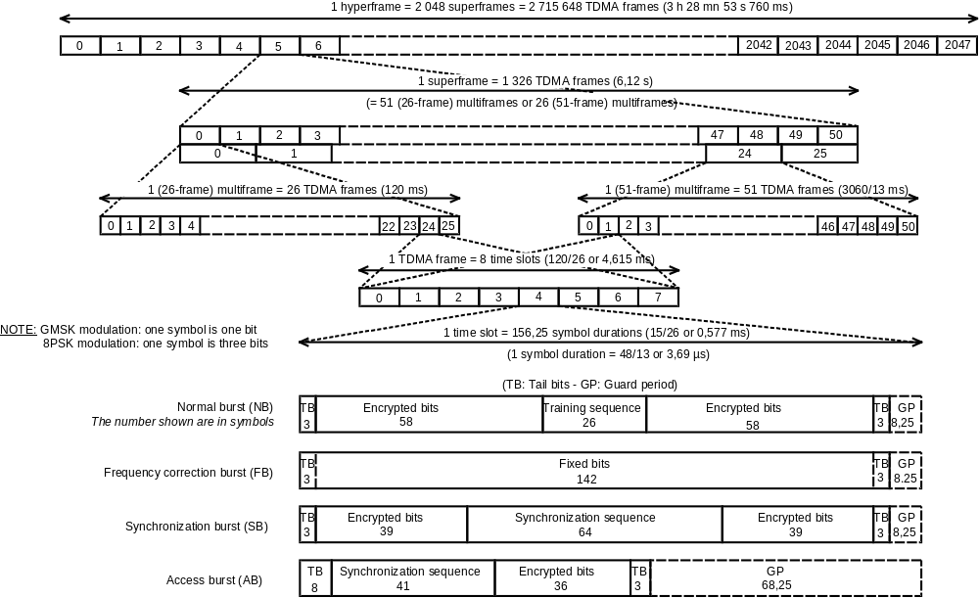Figure 1: Time frames time slots and bursts

5.3 Channel organization
The channel organization for the traffic channels (TCH), FACCHs and SACCH/T uses the 26-frame multiframe. It is organized as described in figure 2, where only one time slot per TDMA frame is considered.
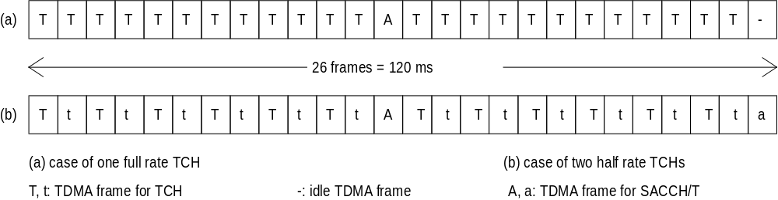

Figure 2: Traffic channel organization
The FACCH is transmitted by pre-empting half or all of the information bits of the bursts of the TCH to which it is associated (see 3GPP TS 45.003).
The channel organization for the control channels (except FACCHs and SACCH/T) uses the 51-frame multiframe. It is organized in the downlink and uplink as described in figure 3.
The channel organization for packet data channels uses the 52- multiframe. Full rate packet data channels are organized as described in figure 2a1. Half rate packet data channels can be organized as described in figure 2a2.
52 TDMA Frames
X = Idle frame
B0 - B11 = Radio blocks

Figure 2a1: 52- multiframe for PDCH/Fs

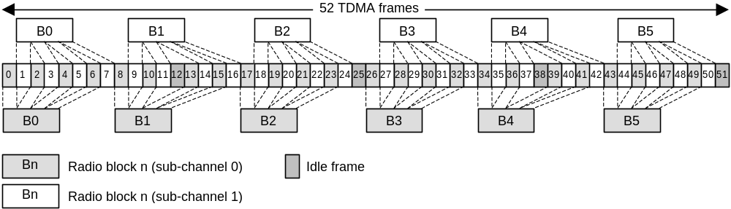

Figure 2a2: 52- multiframe for PDCH/Hs

The channel organization for CTS control channels uses the 52-multiframe. It is organized as described in figure 2b.
52 TDMA Frames
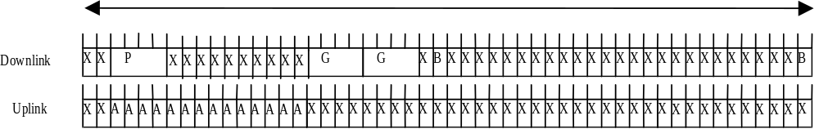
A: TDMA frame for CTSARCH
B: TDMA frame for CTSBCH
P: TDMA frame for CTSPCH
G: TDMA frame for CTSAGCH
X: Idle frame

Figure 2b: 52-multiframe for CTS

6 Frequency hopping capability
The frequency hopping capability is optionally used by the network operator on all or part of its network. The main advantage of this feature is to provide diversity on one transmission link (especially to increase the efficiency of coding and interleaving for slowly moving mobile stations) and also to average the quality on all the communications through interferers diversity. It is implemented on all mobile stations.
The principle of slow frequency hopping is that every mobile transmits its time slots according to a sequence of frequencies that it derives from an algorithm. The frequency hopping occurs between time slots and, therefore, a mobile station transmits (or receives) on a fixed frequency during one time slot (≈ 577 µs) and then must hop before the time slot on the next TDMA frame. Due to the time needed for monitoring other base stations the time allowed for hopping is approximately 1 ms, according to the receiver implementation. The receive and transmit frequencies are always duplex frequencies.
The frequency hopping sequences are orthogonal inside one cell (i.e. no collisions occur between communications of the same cell), and independent from one cell to an homologue cell (i.e. using the same set of RF channels, or cell allocation). The hopping sequence is derived by the mobile from parameters broadcast at the channel assignment, namely, the mobile allocation (set of frequencies on which to hop), the hopping sequence number of the cell (which allows different sequences on homologue cells) and the index offset (to distinguish the different mobiles of the cell using the same mobile allocation). The non-hopping case is included in the algorithm as a special case. The different parameters needed and the algorithm are specified in 3GPP TS 45.002.
In case of multi band operation frequency hopping channels in different bands of operation, e.g. between channels in GSM and DCS, is not supported. Frequency hopping within each of the bands supported shall be implemented in the mobile station.
It must be noted that the basic physical channel supporting the BCCH does not hop.
For COMPACT, frequency hopping is not permitted on CPBCCH or CPCCCH for a specific amount of blocks. On other frequency hopping channels, a reduced mobile allocation is used on the corresponding blocks.
In CTS, the frequency hopping capability shall be used. The frequency hopping sequences are independently chosen by each CTS-FP. The hopping sequence is derived by the CTS-MS from parameters transmitted during the attachment procedure. The different parameters needed and the algorithm are specified in 3GPP TS 45.002. It must be noted that the basic physical channels supporting the CTSBCH and some other particular channels do not hop (see GMS 45.002).

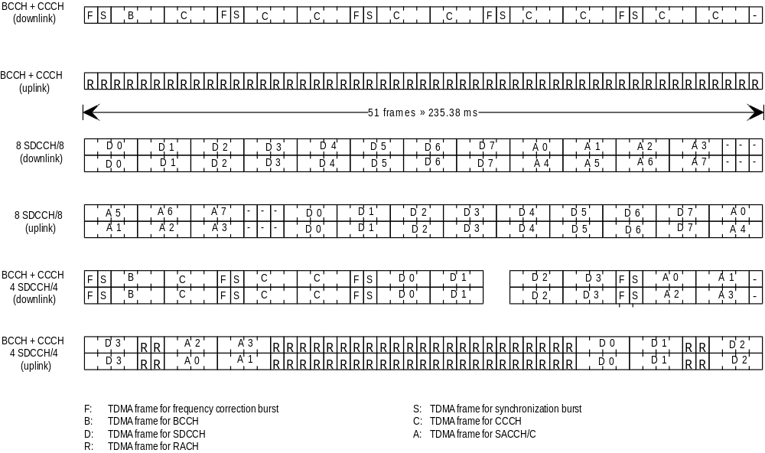

Figure 3: Channel organization in the 51-frame multiframe

7 Coding and interleaving

7.1 General
A brief description of the coding schemes that are used for the logical channels mentioned in clause 2, plus the synchronization channel (SCH, see subclause 5.2), is made in the following tables. For all the types of channels the following operations are made in this order:
- external coding (block coding);
- internal coding (convolutional coding);
- interleaving.
After coding the different channels (except RACH, SCH, CTSBCH-SB and CTSARCH) are constituted by blocks of coded information bits plus coded header (the purpose of the header is to distinguish between TCH and FACCH blocks). These blocks are interleaved over a number of bursts. The block size and interleaving depth are channel dependent. All these operations are specified in 3GPP TS 45.003.
For the adaptive speech traffic channels a signaling codeword is attached to the block of coded information bits before interleaving. The signaling codeword is a block code representation of a 2-bits inband information word (rate ¼ for the adaptive full rate speech traffic channels and ½ for the adaptive half rate speech traffic channels)
Type of channel | bits/block data+parity+tail1 | convolutional code rate | coded bits per block | interleaving depth
TCH/FS |  |  | 456 | 8
class I2 | 182 + 3 + 4 | 1/2 | 378
class II | 78 + 0 + 0 | - | 78
TCH/EFS |  |  | 456 | 8
class I2 | 170 + 15 + 4 | 1/2 | 378
class II | 74 + 4 + 0 | - | 78
TCH/HS |  |  | 228 | 4
class I3 | 95+3+6 | 104/211 | 211
class II | 17+0+0 |  | 17
TCH/AFS12.24 |  |  | 456 | 8
Class I5 | 244 + 6 + 4 | 127/224 | 448
TCH/AFS10.24 |  |  | 456 | 8
Class I6 | 204 + 6 + 4 | 12/224 | 448
TCH/AFS7.954 |  |  | 456 | 8
Class I7 | 159 + 6 + 6 | 171/448 | 448
TCH/AFS7.44 |  |  | 456 | 8
Class I8 | 148 + 6 + 4 | 79/224 | 448
TCH/AFS6.74 |  |  | 456 | 8
Class I9 | 134 + 6 + 4 | 9/28 | 448
TCH/AFS5.94 |  |  | 456 | 8
Class I10 | 118 + 6 + 6 | 75/224 | 448
TCH/AFS5.154 |  |  | 456 | 8
Class I11 | 103 + 6 + 4 | 113/448 | 448
TCH/AFS4.754 |  |  | 456 | 8
Class I12 | 95 + 6 + 6 | 107/448 | 448
TCH/AHS7.9513 |  |  | 228 | 4
Class I14 | 123 + 6 + 4 | 133/188 | 188
Class II | 36+0+0 |  | 36
TCH/AHS7.413 |  |  | 228 | 4
Class I15 | 120 + 6 + 4 | 65/98 | 196
Class II | 28+0+0 |  | 28
TCH/AHS6.713 |  |  | 228 | 4
Class I16 | 110 + 6 + 4 | 3/5 | 200
Class II | 24+0+0 |  | 24
TCH/AHS5.913 |  |  | 228 | 4
Class I17 | 102 + 6 + 4 | 7/13 | 208
Class II | 16+0+0 |  | 16
TCH/AHS5.1513 |  |  | 228 | 4
Class I18 | 91 + 6 + 4 | 101/212 | 212
Class II | 12+0+0 |  | 12
TCH/AHS4.7513 |  |  | 228 | 4
Class I19 | 83 + 6 + 6 | 95/212 | 212
Class II | 12+0+0 |  | 12
(continued)
(concluded)
Type of channel | bits/block data+parity+tail1 | convolutional code rate | coded bits per block | interleaving depth
TCH/F14.4  TCH/F9.6 | 290 + 0 + 4  4*60 + 0 + 4 | 294/456  244/456 | 294/456  456 | 19  19
TCH/F4.8 | 60 + 0 + 16 | 1/3 | 228 | 19
TCH/H4.8 | 4*60 + 0 + 4 | 244/456 | 456 | 19
TCH/F2.4 | 72 + 0 + 4 | 1/6 | 456 | 8
TCH/H2.4 | 72 + 0 + 4 | 1/3 | 228 | 19
FACCH/F | 184 + 40 + 4 | 1/2 | 456 | 8
E-FACCH/F | 184 + 40 + 4 | 1/2 | 456 | 4
FACCH/H | 184 + 40 + 4 | 1/2 | 456 | 6
SDCCHs SACCHs BCCH NCH AGCH PCH
CBCH | 184 + 40 + 4 | 1/2 | 456 | 4
RACH | 8 + 6 + 4 | 1/2 | 36 | 1
SCH | 25 + 10 + 4 | 1/2 | 78 | 1
CTSBCH-SB | 25 + 10 + 4 | 1/2 | 78 | 1
CTSPCH | 184 + 40 + 4 | 1/2 | 456 | 4
CTSARCH | 25 + 10 + 4 | 1/2 | 78 | 1
CTSAGCH | 184 + 40 + 4 | 1/2 | 456 | 4
NOTE 1: The tail bits mentioned here are the tail bits of the convolutional code.

NOTE 2: The 3 parity bits for TCH/FS detect an error on 50 bits of class I.

NOTE 3: The 3 parity bits for TCH/HS detect an error on 22 bits of class I.
NOTE 4: For TCH/AFS an 8 bits in band signalling codeword is attached to the block of coded information before interleaving.
A dedicated block structure to carry the comfort noise information associated with the adaptive full rate speech traffic channels is also specified in 3GPP TS 45.003.
NOTE 5: The 6 parity bits for TCH/AFS12.2 detect an error on 81 bits of class I.
NOTE 6: The 6 parity bits for TCH/AFS10.2 detect an error on 65 bits of class I.
NOTE 7: The 6 parity bits for TCH/AFS7.95 detect an error on 75 bits of class I.
NOTE 8: The 6 parity bits for TCH/AFS7.4 detect an error on 61 bits of class I.
NOTE 9: The 6 parity bits for TCH/AFS6.7 detect an error on 55 bits of class I.
NOTE 10: The 6 parity bits for TCH/AFS5.9 detect an error on 55 bits of class I.
NOTE 11: The 6 parity bits for TCH/AFS5.15 detect an error on 49 bits of class I.
NOTE 12: The 6 parity bits for TCH/AFS4.75 detect an error on 39 bits of class I.
NOTE 13: For TCH/AHS a 4 bits in band signalling codeword is attached to the block of coded information before interleaving
A dedicated block structure to carry the comfort noise information associated with the adaptive half rate speech traffic channels is also specified in 3GPP TS 45.003.
NOTE 14: The 6 parity bits for TCH/AHS7.95 detect an error on 67 bits of class I.
NOTE 15: The 6 parity bits for TCH/AHS7.4 detect an error on 61 bits of class I.
NOTE 16: The 6 parity bits for TCH/AHS6.7 detect an error on 55 bits of class I.
NOTE 17: The 6 parity bits for TCH/AHS5.9 detect an error on 55 bits of class I.
NOTE 18: The 6 parity bits for TCH/AHS5.15 detect an error on 49 bits of class I.
NOTE 19: The 6 parity bits for TCH/AHS4.75 detect an error on 39 bits of class I.

Type of channel | bits/block data+parity+tail1 | Reed-Solomon code rate | convolutional code rate | coded bits per block | interleaving depth
E-TCH/F43.2  E-TCH/F32.0  E-TCH/F28.8 | 870 + 0 + 6  640 + 0 + 6  580 + 0 + 6 | N/A  80/92  73/85 | 876/1368  742/1368  686/1368 | 1368  1368  1368 | 19  19  19

7.2 Packet Traffic and Control Channels
All packet traffic and control channels, except PRACH, use rectangular interleaving of one Radio Block over four bursts in consecutive TDMA frames.

7.2.1 Channel coding for PDTCH

7.2.1.1 Channel coding for GPRS PDTCH
Four different coding schemes, CS-1 to CS-4, are defined for the GPRS Radio Blocks carrying RLC data blocks. For the Radio Blocks carrying RLC/MAC Control blocks code CS-1 is always used. The exception are messages that use the existing Access Burst [9] (e.g. Packet Channel Request). An additional coding scheme is defined for the Access Burst that includes 11 information bits.
The first step of the coding procedure is to add a Block Check Sequence (BCS) for error detection. For CS-1 - CS-3, the second step consists of pre-coding USF (except for CS-1), adding four tail bits and a convolutional coding for error correction that is punctured to give the desired coding rate. For CS-4 there is no coding for error correction.
The details of the codes are shown in the table below, including:
- the length of each field;
- the number of coded bits (after adding tail bits and convolutional coding);
- the number of punctured bits;
- the data rate, including the RLC header and RLC information.
Scheme | Code rate | USF | Pre-coded USF | Radio Block excl. USF and BCS | BCS | Tail | Coded  bits | Punctured  bits
CS-1 | 1/2 | 3 | 3 | 181 | 40 | 4 | 456 | 0
CS-2 | ≈2/3 | 3 | 6 | 268 | 16 | 4 | 588 | 132
CS-3 | ≈3/4 | 3 | 6 | 312 | 16 | 4 | 676 | 220
CS-4 | 1 | 3 | 12 | 428 | 16 | - | 456 | -

CS-1 is the same coding scheme as specified for SDCCH. It consists of a half rate convolutional code for FEC and a 40 bit FIRE code for BCS (and optionally FEC). CS-2 and CS-3 are punctured versions of the same half rate convolutional code as CS-1 for FEC. CS-4 has no FEC.
The USF has 8 states, which are represented by a binary 3 bit field in the MAC Header.
All coding schemes are mandatory for MSs supporting GPRS. Only CS-1 is mandatory for the network.

7.2.1.2 Channel coding for EGPRS PDTCH
Nine different modulation and coding schemes, MCS-1 to MCS-9, are defined for the EGPRS Radio Blocks (4 bursts, 20ms) carrying RLC data blocks. For the Radio Blocks carrying RLC/MAC Control blocks code CS-1 is always used. The exception are messages that use the existing Access Burst [9] (e.g. Packet Channel Request). An additional coding scheme is defined for the Access Burst that includes 11 information bits.
To ensure strong header protection, the header part of the Radio Block is independently coded from the data part of the Radio Block (8 bit CRC calculated over the header -excl. USF- for error detection, followed by rate 1/3 convolutional coding –and eventually puncturing- for error correction).
The MCSs are divided into different families A, B and C. Each family has a different basic unit of payload (see 3GPP TS 43.064 [16]). Different code rates within a family are achieved by transmitting a different number of payload units within one Radio Block. For families A and B, 1, 2 or 4 payload units are transmitted, for family C, only 1 or 2 payload units are transmitted.
When 4 payload units are transmitted (MCS-7, MCS-8 and MCS-9), these are splitted into two separate RLC blocks (i.e. with separate sequence numbers and block check sequences).

The first step of the coding procedure is to add a Block Check Sequence (BCS) for error detection.
The second step consists of adding six tail bits (TB) and a 1/3 rate convolutional coding for error correction that is punctured to give the desired coding rate.
The USF has 8 states, which are represented by a binary 3 bit field in the MAC Header. The USF is encoded to 12 symbols similarly to GPRS, (12 bits for GMSK modes and 36 bits for 8PSK modes).
Coding schemes MCS-1 to MCS-9 are mandatory for MSs supporting EGPRS. A network supporting EGPRS may support only some of the MCSs.
The details of the EGPRS coding schemes are shown in the table below. An exhaustive description of the EGPRS coding schemes can be found in 3GPP TS 45.003 [9].

Coding parameters for the EGPRS coding schemes
Scheme | Code rate | Header Code rate | Modulation | RLC blocks per Radio Block (20ms) | Raw Data within one Radio Block | Family | BCS | Tail payload | HCS | Data rate  kb/s
MCS-9 | 1.0 | 0.36 | 8PSK | 2 | 2x592 | A | 2x12 | 2x6 | 8 | 59.2
MCS-8 | 0.92 | 0.36 | 8PSK | 2 | 2x544 | A | 2x12 | 2x6 | 8 | 54.4
MCS-7 | 0.76 | 0.36 | 8PSK | 2 | 2x448 | B | 2x12 | 2x6 | 8 | 44.8
MCS-6 | 0.49 | 1/3 | 8PSK | 1 | 592  544+48 | A | 12 | 6 | 8 | 29.6  27.2
MCS-5 | 0.37 | 1/3 | 8PSK | 1 | 448 | B | 12 | 6 | 8 | 22.4
MCS-4 | 1.0 | 0.53 | GMSK | 1 | 352 | C | 12 | 6 | 8 | 17.6
MCS-3 | 0.80 | 0.53 | GMSK | 1 | 296  272+24 | A | 12 | 6 | 8 | 14.8  13.6
MCS-2 | 0.66 | 0.53 | GMSK | 1 | 224 | B | 12 | 6 | 8 | 11.2
MCS-1 | 0.53 | 0.53 | GMSK | 1 | 176 | C | 12 | 6 | 8 | 8.8

Note: The italic captions indicate the padding.

7.2.2 Channel coding for PACCH, PBCCH, PAGCH, PPCH, PNCH, CPBCCH, CPAGCH, CPPCH, CPNCH, and CSCH
The channel coding for the PACCH, PBCCH, PAGCH, PPCH, PNCH, CPBCCH, CPAGCH, CPPCH, and CPNCH is corresponding to the coding scheme CS-1. The channel coding for the CSCH is identical to SCH.

7.2.3 Channel Coding for the PRACH
Two types of packet random access burst may be transmitted on the PRACH: an 8 information bits random access burst or an 11 information bits random access burst called the extended packet random access burst. The MS shall support both random access bursts. The channel coding used for the burst carrying the 8 data bit packet random access uplink message is identical to the coding of the random access burst on the RACH. The channel coding used for the burst carrying the 11 data bit packet random access uplink message is a punctured version of the coding of the random access burst on the RACH

8 Modulations
The modulation scheme may be either gaussian MSK (GMSK) with BT = 0,3 or 8-PSK, depending on the type of channel. As already mentioned the modulation rate is 1 625/6 ksymbol/s (≈ 270,83 ksymbol/s). This scheme is specified in detail in 3GPP TS 45.004 (Modulation and demodulation) [10].

9 Transmission and reception
The modulated stream is then transmitted on a radio frequency carrier. The frequency bands and channel arrangements are the following:
i) GSM 450 Band;
For GSM 450, the system is required to operate in the following frequency band:
450.4 – 457.6 MHz: mobile transmit, base receive;
460.4 – 467.6 MHz: base transmit, mobile receive;
ii) GSM 480 Band;
For GSM 480, the system is required to operate in the following frequency band:
478.8 – 486 MHz: mobile transmit, base receive;
488.8 – 496 MHz: base transmit, mobile receive;
iii) GSM 700 Band;
For GSM 700, the system is required to operate in the following frequency band:
777 – 792 MHz: mobile transmit, base receive;
747 – 762 MHz: base transmit, mobile receive;
iv) GSM 850 Band;
For 850, the system is required to operate in the following band:
824 - 849 MHz: mobile transmit, base receive
869 - 894 MHz: base transmit, mobile receive
v) Standard or primary GSM 900 Band, P-GSM;
For Standard GSM 900 Band, the system is required to operate in the following frequency band:
890 - 915 MHz: mobile transmit, base receive
935 - 960 MHz: base transmit, mobile receive
vi) Extended GSM 900 Band, E-GSM (includes Standard GSM 900 band);
For Extended GSM 900 Band, the system is required to operate in the following frequency band:
880 - 915 MHz: mobile transmit, base receive
925 - 960 MHz: base transmit, mobile receive
vii) Railways GSM 900 Band, R-GSM (includes Standard and Extended GSM 900 Band);
For Railways GSM 900 Band, the system is required to operate in the following frequency band:
876 - 915 MHz: mobile transmit, base receive
921 - 960 MHz: base transmit, mobile receive
viii) DCS 1 800 Band;
For DCS 1 800, the system is required to operate in the following frequency band:
1 710 - 1 785 MHz: mobile transmit, base receive
1 805 - 1 880 MHz: base transmit, mobile receive
ix) PCS 1900 Band;
For PCS 1900, the system is required to operate in the following frequency band;
1850-1910 MHz: mobile transmit, base receive
1930-1990 MHz: base transmit, mobile receive
NOTE 1: The term GSM 400 is used for any GSM system, which operates in any 400 MHz band.
NOTE 2: The term GSM 700 is used for any GSM system, which operates in any 700 MHz band.
NOTE 3: The term GSM 850 is used for any GSM system, which operates in any 850 MHz band.
NOTE 4: The term GSM 900 is used for any GSM system, which operates in any 900 MHz band.
NOTE 5: The BTS may cover a complete band, or the BTS capabilities may be restricted to a subset only, depending on the operator needs.
Operators may implement networks on a combination of the frequency bands above to support multi band mobile stations, which are defined in 3GPP TS 02.06.
The RF channel spacing is 200 kHz, allowing for 35 (GSM 450), 35 (GSM 480), 74 (GSM 700), 124 (GSM 850), 194 (GSM 900), 374 (DCS 1 800) and 299 (PCS 1900) radio frequency channels, thus leaving a guard band of 200 kHz at each end of the sub-bands.
The specific RF channels, together with the requirements on the transmitter and the receiver will be found in 3GPP TS 45.005 (Transmission and reception) and in 3GPP TS 45.056 for the CTS-FP.
In order to allow for low power consumption for different categories of mobiles (e.g. vehicle mounted, hand-held, ..), different power classes have been defined. For GSM 400, GSM 700, GSM 850 and GSM 900 there are four power classes with the maximum power class having 8 W peak output power (ca 1 W mean output power) and the minimum having 0,8 W peak output power. For DCS 1 800 there are three power classes of 4 W peak output power, 1 W peak output power (ca 0,125 W mean) and 0,25 W peak output power. For PCS 1900 there are three power classes of 2 watts, 1 watt and .25 watt peak output power.
Multi band mobile stations may have any combinations of the allowed power classes for each of the bands supported.
The power classes are specified in 3GPP TS 45.005 and in 3GPP TS 45.056 for CTS-FP.
The requirements on the overall transmission quality together with the measurement conditions are also in 3GPP TS 45.005 and in 3GPP TS 45.056 for CTS-FP.

10 Other layer 1 functions
The transmission involves other functions. These functions may necessitate the handling of specific protocols between BS and MS. Relevant topics for these cases are:
1) The power control mechanisms which adjust the output level of the mobile station (and optionally of the base station) in order to ensure that the required quality is achieved with the less possible radiated power. Power levels with 2 dB steps have been defined for that purpose. This is described in 3GPP TS 45.008 (radio subsystem link control) and 3GPP TS 45.005.
2) The synchronization of the receiver with regard to frequency and time (time acquisition and time frame alignment). The synchronization problems are described in 3GPP TS 45.010 (synchronization aspects).
3) The hand-over and quality monitoring which are necessary to allow a mobile to continue a call during a change of physical channel. This can occur either because of degradation of the quality of the current serving channel, or because of the availability of another channel which can allow communication at a lower Tx power level, or to prevent a MS from grossly exceeding the planned cell boundaries. In the case of duplex point-to-point connections, the choice of the new channel is done by the network (base station control and MSC) based on measurements (on its own and on adjacent base stations) that are sent on a continuous basis by the mobile station via the SACCHs. The requirements are specified in 3GPP TS 45.008 (radio subsystem link control).
4) The measurements and sub-procedures used in the first selection or reselection of a base station by a mobile are specified in 3GPP TS 45.008 (radio subsystem link control). The overall selection and reselection procedures, together with the idle mode activities of a mobile are defined in 3GPP TS 43.022 (functions related to MS in idle mode and group receive mode and GPRS mode ).
5) The measurements and sub-procedures used by an MS in selecting a base station for reception of a voice group or a voice broadcast call are specified in 3GPP TS 45.008 (radio subsystem link control). The overall voice group and voice broadcast cell change procedures, being similar to the reselection procedures related to the idle mode activities of an MS, are defined in 3GPP TS 43.022 (functions related to MS in idle mode and group receive mode and GPRS mode ).
6) For the adaptive speech traffic channels the inband signalling carries the required information to adapt the speech and channel codec modes to the propagation conditions. The coding of the in band signalling is specified in 3GPP TS 45.009 (Link adaptation). An example of codec adaptation algorithm is also provided in 3GPP TS 45.009 (Link adaptation).

11 Performance
Under typical urban fading conditions (i.e. multipath delays no greater than 5 µs), the quality threshold for full-rate speech and PDTCH/CS1 is reached at a C/I value of approximately 9 dB. The maximum sensitivity is approximately -104 dBm for base stations and GSM mobiles and -102 dBm for GSM small MSs and PCS 1900 MS s and -100 dBm for DCS 1 800 hand-helds (see 3GPP TS 45.005).
Multi band MSs shall meet the requirements on each band of operation respectively.

Annex A (informative):
Reference configuration
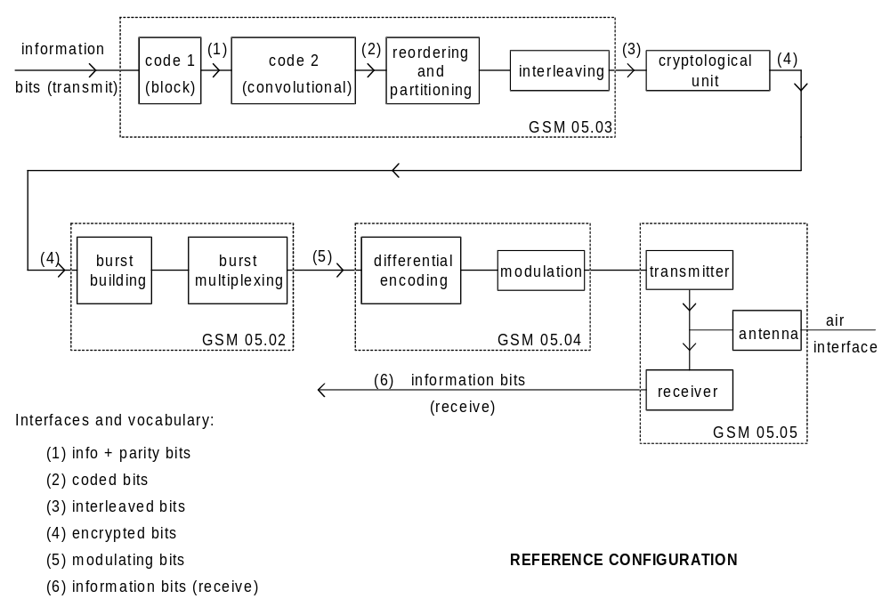

Annex B (informative):
Relations between specification
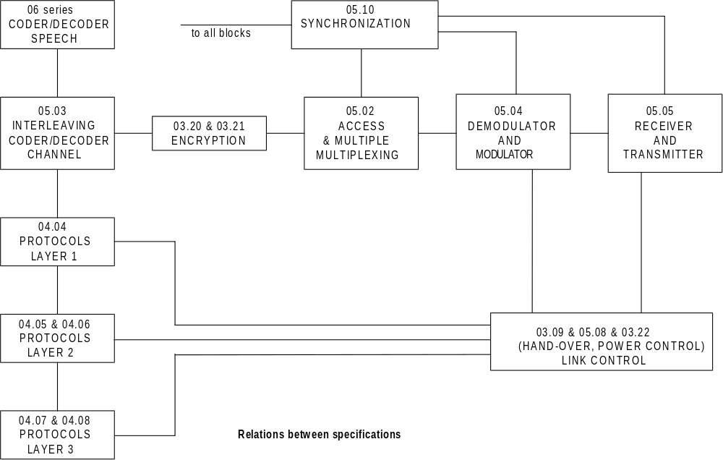

Annex C (informative):
Change control history
SPEC | SMG# | CR | PHASE | VERS |  | NEW_VERS |  | SUBJECT
05.01 | S18 | A005 | 2+ | 4.6.0 | 5.0.0 |  | Addition of ASCI features
05.01 | S20 | A006 | 2+ | 5.0.0 | 5.1.0 |  | Introduction of high speed circuit switched data
05.01 | s21 | A007 | 2+ | 5.1.0 | 5.2.0 |  | Introduction of R-GSM band
05.01 | s22 | A009 | 2+ | 5.2.0 | 5.3.0 |  | Clarification of the frequency definition text in section 9
05.01 | s24 | A010 | R97 | 5.3.0 | 6.0.0 |  | Introduction of GPRS
05.01 | s25 | A012 | R97 | 6.0.0 | 6.1.0 |  | 14.4kbps Data Service
05.01 | s25 | A013 | R97 | 6.0.0 | 6.1.0 |  | Renaming of GPRS RR states
05.01 | s28 | A014 | R98 | 6.1.1 | 7.0.0 |  | Harmonization between GSM and PCS 1900 standard
05.01 | s28 | A015 | R98 | 6.1.1 | 7.0.0 |  | Introduction of CTS in 05.01
05.01 | s28 | A016 | R98 | 6.1.1. | 7.0.0 |  | Introduction of AMR in 05.01
05.01 | s29 | A017 | R99 | 7.0.0. | 8.0.0 |  | Introduction of GSM 400 in 05.01
05.01 | s29 | A018 | R99 | 7.0.0 | 8.0.0 |  | 05.01 changes for ECSD FACCH
05.01 | s30 | A020 | R99 | 8.0.1 | 8.1.0 |  | Correction of AMR Block Structure Parameters, Introduction of TCH/EFS
05.01 | s30 | A021 | R99 | 8.0.1 | 8.1.0 |  | Introduction of the definition of the PDTCH for EGPRS
05.01 | s30 | A022 | R99 | 8.0.1 | 8.1.0 |  | EDGE Compact logical channels
05.01 | s30b | A023 | R99 | 8.1.0 | 8.2.0 |  | Support of Slow Frequency Hopping for EGPRS COMPACT
05.01 | s31 | A024 | R99 | 8.2.0 | 8.3.0 |  | Complete Frequency Hopping on COMPACT
05.01 | s32 | A026 | R99 | 8.3.0 | 8.4.0 |  | Definition of PDCH/H and alignment with DTM
 |  |  |  |  |  |  | September 2000 - 3GPP TSG-GERAN
05.01 | G01 | A028 | R99 | 8.4.0 | 8.5.0 |  | CR 05.01-A028 DTM (R99)
05.01 | G01 | A029 | R99 | 8.4.0 | 8.5.0 |  | CR 05.01-A029 DTM+EGPRS (R99)
05.01 | G01 | A031 | R99 | 8.4.0 | 8.5.0 |  | CR 05.01-A031 Minimum Mobile Station Class and Channelization Capabilities
GERAN |  |  |  |  |  |  | Release 4
05.01 / 45.001 | G01 | A030 | Rel4 | 8.5.0 | 4.0.0 |  | CR 05.01-A030 Introduction of GSM 700 (Release 4)

One symbol is either one or three bits depending on the modulation used: GMSK or 8PSK.

